CSA0315 – DATA STRCTURE
CO3 – AT2 (TREE TRAVERSAL VISUALIZATION)
VISUALIZE TREE TRAVERSAL

Faculty: By:
Dr. T. Rajesh Kumar G.Manish(192210591)

1) Construct a Binary Search Tree (BST) using the dataset
45,20,60,10,30,50,70,25,35

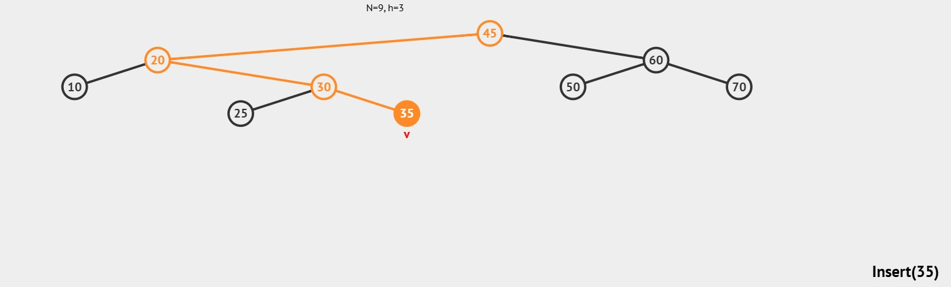

- Construct an AVL Tree using the elements 50,30,70,20,40,60,80 perform the required operations and document the results. Delete node 30
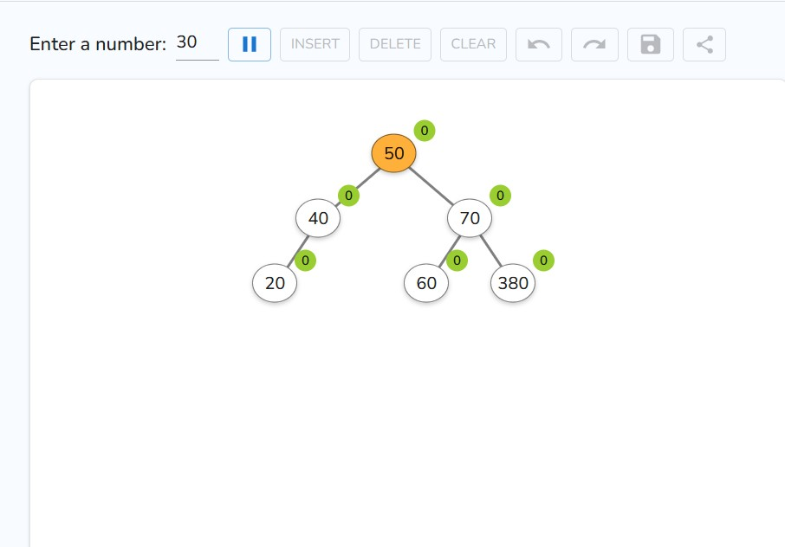

- Construct a Red-Black Tree using {45, 35, 55, 25, 40, 50, 60}, delete the node 35, and explain how violations are fixed using rotations and recoloring
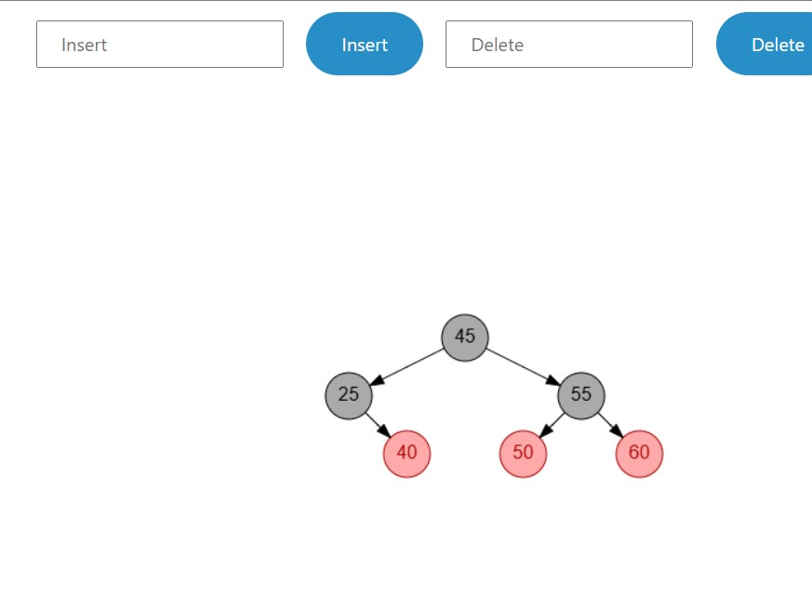

- Develop a Splay Tree with elements {100, 50, 200, 40, 30, 20}, perform a search operation for 20, and demonstrate the zig-zig rotations that bring it to the root 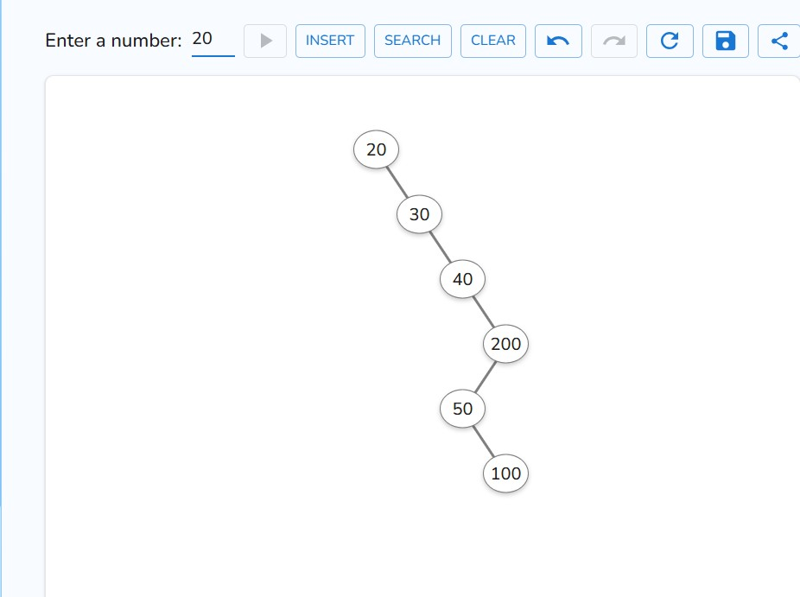

- Create a 2-3-4 Tree for the dataset {50, 40, 60, 30, 70, 20, 80}, perform insertions step-by-step, and show how 4-nodes are split during the process.
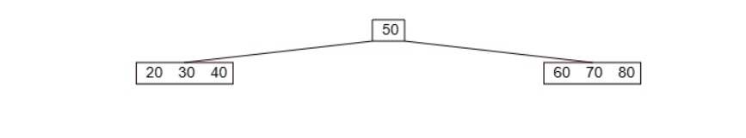

- Construct a Trie using the words {cat, car, care, dog, dot}, perform insertion for all words, search for the prefix “ca”, and delete the word “car” while maintaining the Trie structure.
